Backup Documentation Project – Part 1

1. Summary of the scope:
   1. Organization: A managed service provider for small businesses provides backups as one of their services to their clients. This project will be focusing on server backups in particular. This company internally requires that they provide two types of backups for each of their client’s servers. That includes a cloud backup and a physical on premise backup.
   2. Requirements: The company is currently looking for a solution to be able to easily pull up the following information.
      1. Which clients have backups (onprem/cloud)
      2. Which clients do not have backups (onprem/cloud)
      3. What is getting backed up to where
      4. What are the roles of the server and are those roles getting backed up
      5. Employees need to be able to access the system and view/modify according to their position
   3. Purpose: The purpose of this system is to efficiently answer the above questions for the client. Using a spreadsheet is currently not an effective solution, so the client has asked that we come up with a relational database to hold the necessary information.
2. 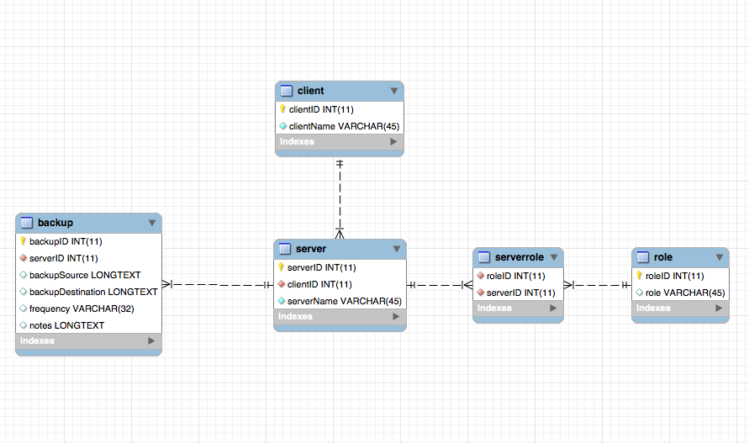
3. The data is already normalized.
   1. It is first normal form because there are no repeating columns, or values within the data.
   2. It is second and third normal form because all non-key values depend completely and only on the primary key.